AI-Based Crop Disease Detection
Anirudh Maity|Ancel Tom Saji|Kalyani Ghadge|Shruti Nagoji Patil
Dr. Atul Kathole
Introduction
Conversational AI assistants transmit every user query — including sensitive personal and financial data such as PINs, account numbers, phone numbers, government IDs, and addresses — in full and in plaintext to third-party LLM providers, with no technical barrier preventing that data from being logged, cached, or exposed through misconfiguration or breach. ConsentChain is proposed as a local, provider-agnostic masking-and-detokenization firewall that intercepts a user's query before transmission, detects sensitive entities, replaces them with reversible tokens, and restores the real values only on the user's own device once the LLM's response returns — ensuring that no sensitive value ever leaves the device in plaintext, while the AI assistant still produces a fully useful, coherent answer.
Literature Review
Sr. No. | Paper Title and Year | Details of Publication | Findings
1 | Paper 1 (2025) | arXiv | Presents a scalable memory layer for AI agents but does not address whether sensitive entities should be masked before ever reaching the LLM.
2 | Paper 2 (2026) | Microsoft open-source fourm | Accurate rule + NER based entity detection, but built for enterprise pipelines, not a provider-agnostic, user-side firewall in front of chat interfaces.
3 | Paper 3 (2026) | arXiv | Proposes realistic surrogate substitution over blank redaction, but does not define a full interception architecture or an on-device vault for detokenization.

Drawbacks of Existing System
- Existing memory frameworks (Mem0, MemGPT, OpenMemory) manage what an LLM can recall but do not decide whether a sensitive value should be transmitted to the provider in the first place.
- Existing enterprise redaction tools (Presidio) are built to be embedded into a single organization's pipeline and require integration effort per platform rather than working transparently in front of any chat interface.
- Existing surrogate-substitution research (SurrogateShield) improves response utility over blank redaction but does not specify a provider-agnostic interception layer or an on-device encrypted vault.
- None of the existing systems combine local entity detection, reversible masking, provider-agnostic interception, and on-device-only detokenization into a single reusable architecture.
Proposed Methodology
ConsentChain follows a five-stage, on-device pipeline. A local interception layer captures the outgoing query; a hybrid regex-and-NER Masking Engine detects sensitive entities; each entity is replaced with a reversible placeholder token; only the masked query is transmitted to the external LLM; and, on the response returning, a local Detokenizer restores the real values using the mapping held in an AES-256 encrypted local Vault. This shifts the point of trust from a remote provider's infrastructure — which cannot be independently verified — to hardware the user already owns and controls.
Proposed Architecture Diagram
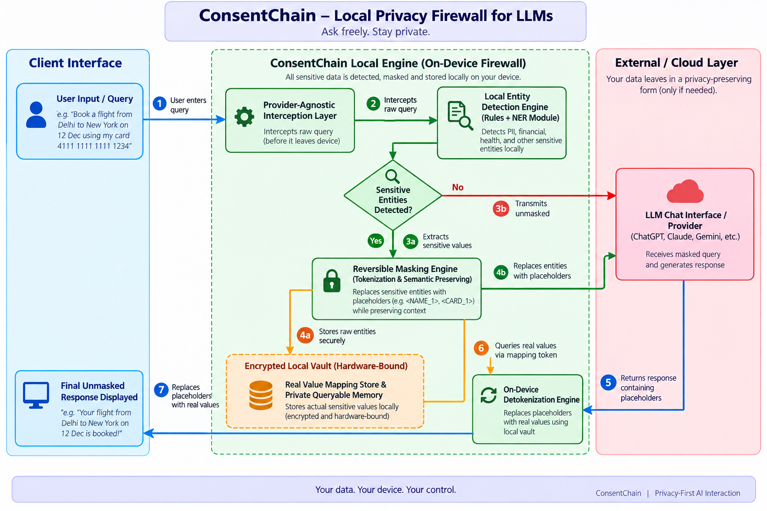
Algorithm
Step 1: Local Interception — a lightweight local HTTP(S) proxy or browser-extension hook captures the outgoing user query before it reaches any LLM provider's network endpoint.
Step 2: Entity Detection — the Masking Engine scans the captured query using a hybrid regex-and-NER pipeline to identify PINs, account numbers, phone numbers, government IDs, and addresses.
Step 3: Reversible Masking — each detected entity is replaced with a semantically neutral placeholder token that preserves the query's grammatical structure.
Step 4: External LLM Call — only the masked query is transmitted to the external LLM provider; the mapping between placeholder and real value never leaves the device.
Step 5: On-Device Detokenization — when the response returns, the local Detokenizer swaps each placeholder back to its real value using the mapping held in the encrypted local Vault.
Step 6: Vault Update — the entity, its token, and the timestamp are logged in the AES-256 encrypted local Vault for auditability.
Step 7: End — the fully reconstructed, real answer is displayed to the user, with zero plaintext ever transmitted externally.
Objectives
- To design a local sensitive-entity detection module that identifies PINs, account numbers, phone numbers, government IDs, and addresses before transmission.
- To design a reversible masking scheme that substitutes each detected entity with a placeholder while preserving the query's semantic meaning.
- To build a provider-agnostic interception layer that applies masking and detokenization across different LLM chat interfaces.
- To design a local, AES-256 encrypted vault that stores real values on-device only, used for detokenization and as private, queryable memory.
Module Information
Module 1: Local Interception Layer
Implements a local HTTP(S) proxy or browser-extension hook (TypeScript/Node.js) that transparently captures the outgoing query before it reaches any LLM provider.
Module 2: Entity Detection & Masking Engine
Implements a hybrid regex-plus-fine-tuned-transformer (DistilBERT-class NER) pipeline in Python that detects sensitive entities and replaces them with reversible tokens.
Module 3: Encrypted Local Vault
Implements an AES-256 encrypted, SQLite-backed key-value store that holds the token-to-real-value mapping exclusively on the user's device.
Module 4: Detokenizer
Restores the real values into the LLM's response by looking up each token in the local Vault, producing the final answer shown to the user.
Module 5: Local Dashboard (Frontend + Backend)
A React-based dashboard backed by a local FastAPI service, through which the user reviews detected entities, adjusts masking rules, and inspects the Vault.
Expected Outcome
The expected outcome of this work is a working, provider-agnostic privacy firewall that can be demonstrated in front of any standard LLM chat interface, showing measurable entity-detection accuracy, zero plaintext leakage under adversarial testing, and response quality comparable to an unmasked baseline — together with a filed patent application and this literary work submission covering the masking-and-detokenization architecture.
Conclusion
ConsentChain reframes privacy protection for conversational AI from a promise about what a provider will do with data it has already received, to a verifiable, testable guarantee about what data leaves the user's device in the first place. By combining local entity detection, reversible masking, a provider-agnostic interception layer, and an on-device encrypted vault into a single reusable architecture, this work closes a gap left open by existing memory frameworks and enterprise redaction tooling, and lays the foundation for further research into local-first privacy infrastructure for AI assistants.

